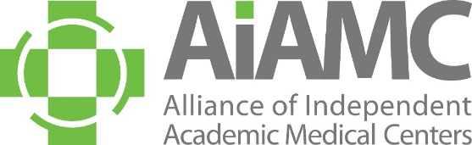

OFFLINE REGISTRATION FORM

Name and Credentials (MD, PhD, Etc.) EXACTLY AS YOU WISH FOR IT TO APPEAR ON YOUR NAME TAG:

Title:
Organization:
E-Mail:

Are You a First-Time Attendee? □ Yes □ No

Registration Fees: Meeting Two

Friday, April 5th

□ $50 Offline Registration (Registrations received after March 8th- only one per institution)

□ $250 Additional Team Leaders and Team Members (only one 0$ per institution)

□ $290 Off-Line Registration (Registrations after March 8th) Additional Team Leaders and Team Members

□ 6:00 pm Awards Dinner ($90) □My guest will accompany me to the Awards Dinner ($90)
Guest Name:

Registration fees include all program materials, 1 breakfast, 2 lunches and 2 breaks. To control costs and keep our registration fees reasonable, we ask that you please make every effort to attend all pre-registered events.

Special Meal Requirements: □ Yes □ No
If yes, please describe:

Payment

□ American Express □ Visa □ MasterCard

Account #:

Amount: Exp. Date: CCID Code:

Cardholder’s Name:

Credit Card Billing Address:

City: State: Zip:

Send completed form to AIAMC Administrative Coordinator Mindi Apicella via email mindi@aiamc.org.
If you prefer to call-in your credit card information, Mindi’s direct line is 407.709.5520.
A receipt will be emailed to the address you provided above.

